- import numpy as np
import pandas as pd
import matplotlib.pyplot as plt
import seaborn as sns
# -------------------------------
# Generate Sample Dataset
# -------------------------------
np.random.seed(10)
n = 150
data = pd.DataFrame({
"Sensor": range(1, n+1),
"PM2.5": np.random.randint(10, 250, n),
"NO2": np.random.randint(5, 180, n),
"CO": np.random.uniform(0.1, 5.0, n),
"Temperature": np.random.randint(20, 45, n),
"Humidity": np.random.randint(30, 95, n),
"X": np.random.randint(1, 21, n),
"Y": np.random.randint(1, 21, n)
})
print(data.head())
# -------------------------------
# Sequential Color Palette
# -------------------------------
plt.figure(figsize=(8,6))
plt.scatter(data["X"], data["Y"],
c=data["PM2.5"],
cmap="Greens",
s=120)
plt.colorbar(label="PM2.5")
plt.title("Sequential Color Palette (Greens)")
plt.xlabel("X Coordinate")
plt.ylabel("Y Coordinate")
plt.grid(True)
plt.show()
# -------------------------------
# Diverging Color Palette
# -------------------------------
plt.figure(figsize=(8,6))
plt.scatter(data["X"], data["Y"],
c=data["PM2.5"],
cmap="coolwarm",
s=120)
plt.colorbar(label="PM2.5")
plt.title("Diverging Color Palette (Coolwarm)")
plt.xlabel("X Coordinate")
plt.ylabel("Y Coordinate")
plt.grid(True)
plt.show()
# -------------------------------
# Qualitative Color Palette
# -------------------------------
colors = sns.color_palette("Set2", 5)
category = pd.cut(data["PM2.5"],
bins=5,
labels=False)
plt.figure(figsize=(8,6))
for i in range(5):
subset = data[category == i]
plt.scatter(subset["X"],
subset["Y"],
color=colors[i],
s=120,
label=f"Group {i+1}")
plt.title("Qualitative Palette (Set2)")
plt.xlabel("X Coordinate")
plt.ylabel("Y Coordinate")
plt.legend()
plt.grid(True)
plt.show()

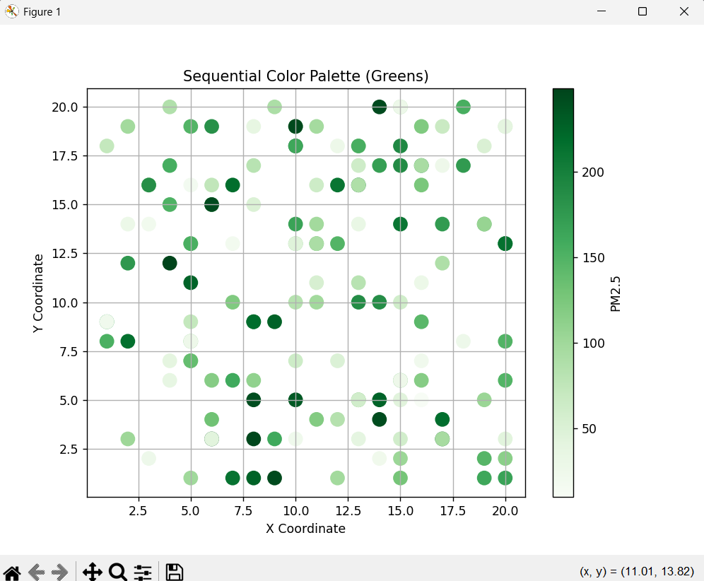
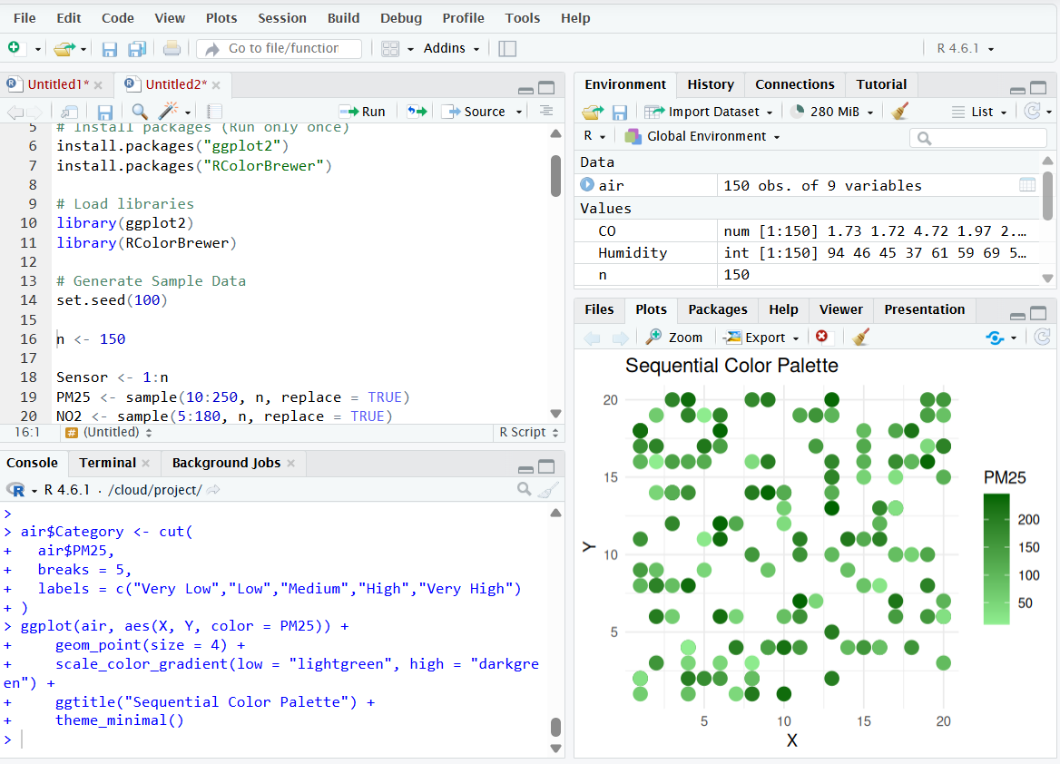

2)
#=========================================
# EXPERIMENT 2
# Earthquake Risk Analysis
#=========================================

# Install package (Run only once)
if (!require(ggplot2)) {
install.packages("ggplot2")
library(ggplot2)
} else {
library(ggplot2)
}

#-----------------------------------------
# Generate Sample Earthquake Data
#-----------------------------------------
set.seed(123)

n <- 1000

Magnitude <- pmin(rexp(n, rate = 1/1.5) + 0.5, 9.5)
Depth <- sample(1:700, n, replace = TRUE)
Latitude <- runif(n, -90, 90)
Longitude <- runif(n, -180, 180)
Aftershock <- sample(0:60, n, replace = TRUE)

earthquake <- data.frame(
Magnitude,
Depth,
Latitude,
Longitude,
Aftershock
)

print(head(earthquake))

#=========================================
# 1. Scatter Plot - Linear Scale
#=========================================

p1 <- ggplot(earthquake,
aes(x = Magnitude,
y = Depth,
color = Aftershock)) +
geom_point(size = 2) +
labs(
title = "Earthquake Distribution - Linear Scale",
x = "Magnitude",
y = "Depth (km)"
) +
theme_minimal()

print(p1)

#=========================================
# 2. Scatter Plot - Log Scale
#=========================================

p2 <- ggplot(earthquake,
aes(x = Magnitude,
y = Depth,
color = Aftershock)) +
geom_point(size = 2) +
scale_y_log10() +
labs(
title = "Earthquake Distribution - Log Scale",
x = "Magnitude",
y = "Depth (Log Scale)"
) +
theme_minimal()

print(p2)

#=========================================
# 3. Histogram - Linear Scale
#=========================================

p3 <- ggplot(earthquake,
aes(x = Magnitude)) +
geom_histogram(
bins = 30,
fill = "skyblue",
color = "black"
) +
labs(
title = "Magnitude Distribution - Linear",
x = "Magnitude",
y = "Frequency"
) +
theme_minimal()

print(p3)

#=========================================
# 4. Histogram - Log Scale
#=========================================

p4 <- ggplot(earthquake,
aes(x = Magnitude)) +
geom_histogram(
bins = 30,
fill = "orange",
color = "black"
) +
scale_y_log10() +
labs(
title = "Magnitude Distribution - Log Scale",
x = "Magnitude",
y = "Frequency (Log)"
) +
theme_minimal()

print(p4)

#=========================================
# End of Program
#=========================================
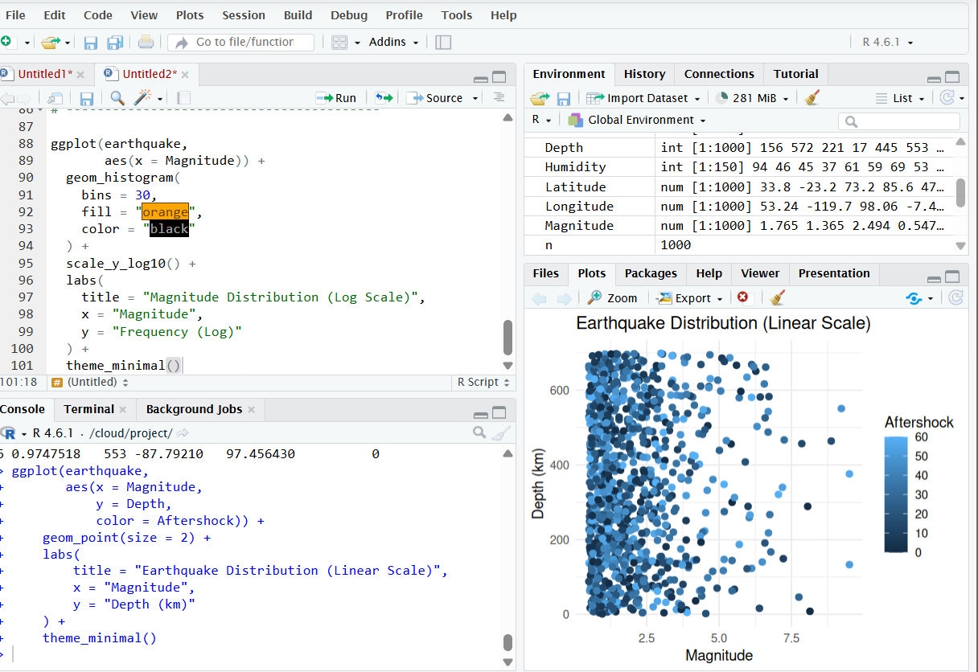

3)
#=========================================
# EXPERIMENT 3
# Wind Direction Analysis for Airport Operations
#=========================================

# Install packages (Run only once)
if (!require(ggplot2)) install.packages("ggplot2")
library(ggplot2)

#-----------------------------------------
# Generate Sample Data
#-----------------------------------------

set.seed(123)

n <- 1000

WindSpeed <- runif(n, 0, 25)
WindDirection <- runif(n, 0, 360)

wind <- data.frame(
WindSpeed,
WindDirection
)

print(head(wind))

#=========================================
# 1. Cartesian Scatter Plot
#=========================================

p1 <- ggplot(wind,
aes(x = 1:n,
y = WindDirection,
color = WindSpeed)) +
geom_point(size = 2) +
labs(
title = "Wind Direction - Cartesian Plot",
x = "Observation",
y = "Wind Direction (Degrees)"
) +
theme_minimal()

print(p1)

#=========================================
# 2. Polar Coordinate Plot
#=========================================

p2 <- ggplot(wind,
aes(x = factor(round(WindDirection/30)*30),
fill = WindSpeed)) +
geom_bar() +
coord_polar() +
labs(
title = "Wind Rose (Polar Coordinate Plot)",
x = "Direction",
y = "Frequency"
) +
theme_minimal()

print(p2)

#=========================================
# 3. Wind Speed Histogram
#=========================================

p3 <- ggplot(wind,
aes(x = WindSpeed)) +
geom_histogram(
bins = 20,
fill = "skyblue",
color = "black"
) +
labs(
title = "Wind Speed Distribution",
x = "Wind Speed (m/s)",
y = "Frequency"
) +
theme_minimal()

print(p3)

#=========================================
# 4. Wind Direction Histogram
#=========================================

p4 <- ggplot(wind,
aes(x = WindDirection)) +
geom_histogram(
bins = 12,
fill = "orange",
color = "black"
) +
labs(
title = "Wind Direction Distribution",
x = "Direction (Degrees)",
y = "Frequency"
) +
theme_minimal()

print(p4)

#=========================================
# End of Program
#=========================================
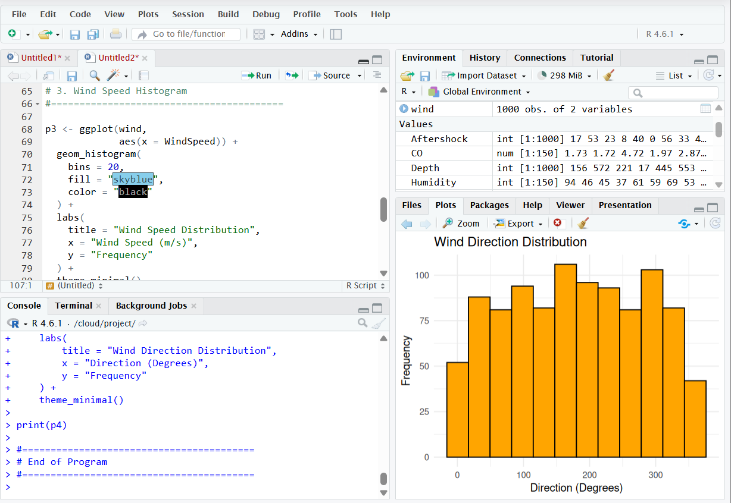

4)
#=========================================
# EXPERIMENT 4
# Hospital Patient Monitoring Dashboard
#=========================================

# Install packages (Run only once)
if (!require(ggplot2)) install.packages("ggplot2")
library(ggplot2)

#-----------------------------------------
# Generate Sample Patient Data
#-----------------------------------------

set.seed(100)

n <- 200

Time <- 1:n
HeartRate <- sample(50:140, n, replace = TRUE)
Oxygen <- sample(85:100, n, replace = TRUE)
SystolicBP <- sample(90:180, n, replace = TRUE)
Respiration <- sample(10:35, n, replace = TRUE)
Temperature <- round(runif(n, 35, 40),1)

patient <- data.frame(
Time,
HeartRate,
Oxygen,
SystolicBP,
Respiration,
Temperature
)

print(head(patient))

#=========================================
# Heart Rate Dashboard
#=========================================

patient$HR_Status <- ifelse(patient$HeartRate < 60 | patient$HeartRate > 100,
"Abnormal","Normal")

p1 <- ggplot(patient,
aes(Time, HeartRate, color = HR_Status)) +
geom_point(size = 2) +
scale_color_manual(values = c("Normal"="green",
"Abnormal"="red")) +
ggtitle("Heart Rate Monitoring") +
theme_minimal()

print(p1)

#=========================================
# Oxygen Saturation Dashboard
#=========================================

patient$O2_Status <- ifelse(patient$Oxygen < 95,
"Low","Normal")

p2 <- ggplot(patient,
aes(Time, Oxygen, color = O2_Status)) +
geom_point(size = 2) +
scale_color_manual(values = c("Normal"="blue",
"Low"="red")) +
ggtitle("Oxygen Saturation") +
theme_minimal()

print(p2)

#=========================================
# Blood Pressure Dashboard
#=========================================

patient$BP_Status <- ifelse(patient$SystolicBP > 140,
"High","Normal")

p3 <- ggplot(patient,
aes(Time, SystolicBP, color = BP_Status)) +
geom_line() +
scale_color_manual(values = c("Normal"="green",
"High"="red")) +
ggtitle("Blood Pressure") +
theme_minimal()

print(p3)

#=========================================
# Temperature Dashboard
#=========================================

patient$Temp_Status <- ifelse(patient$Temperature > 37.5,
"High","Normal")

p4 <- ggplot(patient,
aes(Time, Temperature, color = Temp_Status)) +
geom_line() +
scale_color_manual(values = c("Normal"="blue",
"High"="red")) +
ggtitle("Body Temperature") +
theme_minimal()

print(p4)

#=========================================
# Respiration Dashboard
#=========================================

patient$Resp_Status <- ifelse(patient$Respiration > 20,
"High","Normal")

p5 <- ggplot(patient,
aes(Time, Respiration, color = Resp_Status)) +
geom_line() +
scale_color_manual(values = c("Normal"="green",
"High"="red")) +
ggtitle("Respiration Rate") +
theme_minimal()

print(p5)

#=========================================
# End of Program
#=========================================
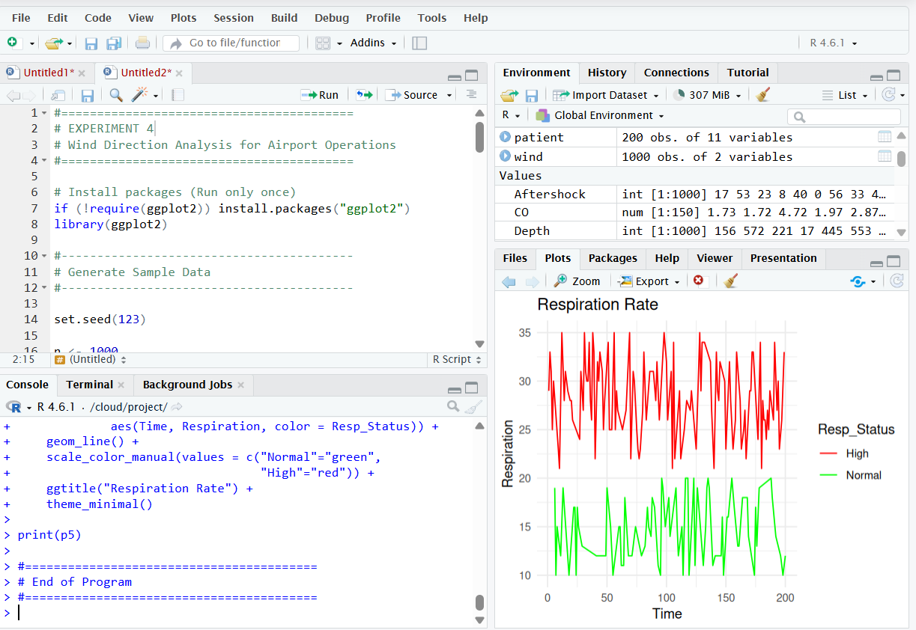
5)
#=========================================
# EXPERIMENT 5
# Global Climate Change Study
#=========================================

# Install packages (Run only once)
if (!require(ggplot2)) install.packages("ggplot2")
if (!require(RColorBrewer)) install.packages("RColorBrewer")

library(ggplot2)
library(RColorBrewer)

#-----------------------------------------
# Generate Sample Data
#-----------------------------------------

set.seed(123)

countries <- paste("Country",1:180)
years <- 1980:2025

climate <- expand.grid(
Country = countries,
Year = years
)

climate$Temperature_Anomaly <- round(runif(
nrow(climate),
-3,
3
),2)

head(climate)

#=========================================
# Heatmap 1 - Blue White Red
#=========================================

p1 <- ggplot(climate,
aes(x=Year,
y=Country,
fill=Temperature_Anomaly))+
geom_tile()+
scale_fill_gradient2(
low="blue",
mid="white",
high="red",
midpoint=0
)+
ggtitle("Temperature Anomalies - Blue White Red")+
theme_minimal()

print(p1)

#=========================================
# Heatmap 2 - Spectral Palette
#=========================================

p2 <- ggplot(climate,
aes(x=Year,
y=Country,
fill=Temperature_Anomaly))+
geom_tile()+
scale_fill_distiller(
palette="Spectral"
)+
ggtitle("Temperature Anomalies - Spectral")+
theme_minimal()

print(p2)

#=========================================
# Heatmap 3 - RdBu Palette
#=========================================

p3 <- ggplot(climate,
aes(x=Year,
y=Country,
fill=Temperature_Anomaly))+
geom_tile()+
scale_fill_distiller(
palette="RdBu",
direction=-1
)+
ggtitle("Temperature Anomalies - RdBu")+
theme_minimal()

print(p3)

#=========================================
# Summary
#=========================================

summary(climate$Temperature_Anomaly) 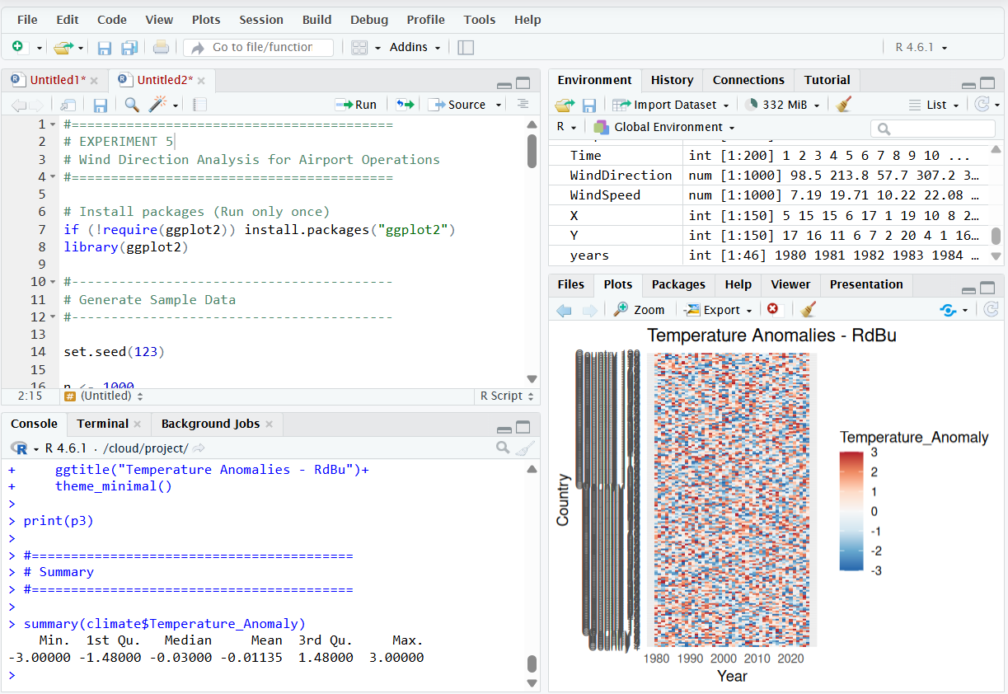

6)
#=========================================
# EXPERIMENT 6
# E-Commerce Sales Analytics
#=========================================

# Install packages (Run only once)
if (!require(ggplot2)) install.packages("ggplot2")
library(ggplot2)

#-----------------------------------------
# Generate Sample Data
#-----------------------------------------

set.seed(123)

Category <- paste("Category", 1:50)
Region <- paste("Region", 1:30)

sales <- expand.grid(
Category = Category,
Region = Region
)

sales$Sales <- sample(1000:100000,
nrow(sales),
replace = TRUE)

head(sales)

#=========================================
# 1. Bubble Chart
#=========================================

p1 <- ggplot(sales,
aes(x = Category,
y = Region,
size = Sales,
color = Category)) +
geom_point(alpha = 0.8) +
ggtitle("Bubble Chart - Sales by Category and Region") +
theme_minimal() +
theme(axis.text.x = element_text(angle = 90))

print(p1)

#=========================================
# 2. Heatmap
#=========================================

p2 <- ggplot(sales,
aes(x = Category,
y = Region,
fill = Sales)) +
geom_tile() +
scale_fill_gradient(low = "yellow",
high = "red") +
ggtitle("Heatmap - Sales Volume") +
theme_minimal() +
theme(axis.text.x = element_text(angle = 90))

print(p2)

#=========================================
# 3. Bar Chart
#=========================================

total_sales <- aggregate(Sales ~ Category,
sales,
sum)

p3 <- ggplot(total_sales,
aes(x = reorder(Category, Sales),
y = Sales,
fill = Sales)) +
geom_col() +
coord_flip() +
scale_fill_gradient(low = "lightblue",
high = "darkblue") +
ggtitle("Total Sales by Category") +
theme_minimal()

print(p3)

#=========================================
# 4. Scatter Plot
#=========================================

p4 <- ggplot(sales,
aes(x = Sales,
y = Region,
color = Category)) +
geom_point(size = 2) +
ggtitle("Sales Distribution") +
theme_minimal()

print(p4)

#=========================================
# End of Program
#=========================================
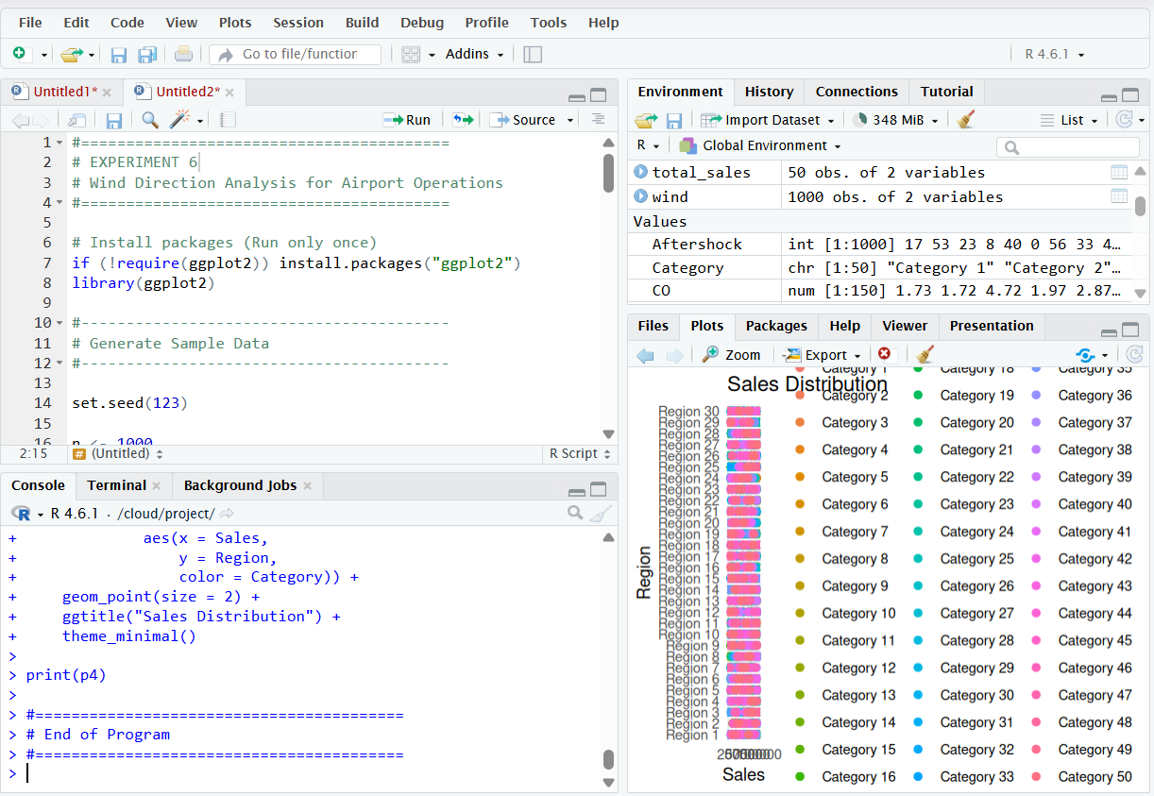

7)
#=========================================
# EXPERIMENT 7
# Satellite Image Vegetation Analysis
#=========================================

# Install packages (Run only once)
if (!require(ggplot2)) install.packages("ggplot2")
library(ggplot2)

#-----------------------------------------
# Generate Sample NDVI Data
#-----------------------------------------

set.seed(123)

n <- 1000

X <- sample(1:100, n, replace = TRUE)
Y <- sample(1:100, n, replace = TRUE)

NDVI <- round(runif(n, -1, 1), 2)

vegetation <- data.frame(
X,
Y,
NDVI
)

head(vegetation)

#=========================================
# 1. Sequential Green Palette
#=========================================

p1 <- ggplot(vegetation,
aes(x = X,
y = Y,
color = NDVI)) +
geom_point(size = 3) +
scale_color_gradient(
low = "yellow",
high = "darkgreen"
) +
ggtitle("Sequential Palette - Vegetation Health") +
theme_minimal()

print(p1)

#=========================================
# 2. Diverging Palette
#=========================================

p2 <- ggplot(vegetation,
aes(x = X,
y = Y,
color = NDVI)) +
geom_point(size = 3) +
scale_color_gradient2(
low = "blue",
mid = "yellow",
high = "darkgreen",
midpoint = 0
) +
ggtitle("Diverging Palette - NDVI") +
theme_minimal()

print(p2)

#=========================================
# 3. NDVI Histogram
#=========================================

p3 <- ggplot(vegetation,
aes(x = NDVI)) +
geom_histogram(
bins = 25,
fill = "forestgreen",
color = "black"
) +
ggtitle("NDVI Distribution") +
theme_minimal()

print(p3)

#=========================================
# 4. NDVI Heatmap
#=========================================

p4 <- ggplot(vegetation,
aes(x = X,
y = Y,
fill = NDVI)) +
geom_tile() +
scale_fill_gradient2(
low = "blue",
mid = "yellow",
high = "darkgreen",
midpoint = 0
) +
ggtitle("NDVI Heatmap") +
theme_minimal()

print(p4)

#=========================================
# NDVI Classification
#=========================================

vegetation$Class <- ifelse(
vegetation$NDVI < 0,
"Water",
ifelse(
vegetation$NDVI < 0.3,
"Barren Land",
"Healthy Vegetation"
)
)

table(vegetation$Class)

#=========================================
# End of Program
#=========================================
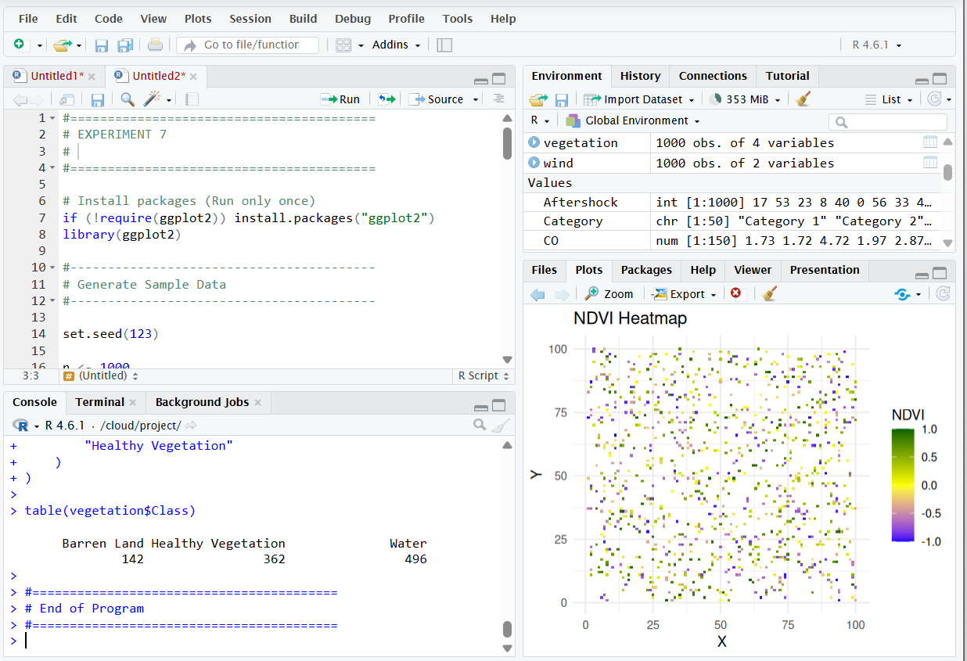

8)
#=========================================
# EXPERIMENT 8
# Cryptocurrency Market Volatility
#=========================================

# Install package (Run only once)
if (!require(ggplot2)) install.packages("ggplot2")
library(ggplot2)

#-----------------------------------------
# Generate Sample Cryptocurrency Data
#-----------------------------------------

set.seed(123)

Days <- 1:365

Bitcoin <- round(runif(365, 30000, 110000),2)
Ethereum <- round(runif(365, 1500, 7000),2)
Solana <- round(runif(365, 20, 350),2)
Cardano <- round(runif(365, 0.2, 3),2)

crypto <- data.frame(
Days,
Bitcoin,
Ethereum,
Solana,
Cardano
)

head(crypto)

#=========================================
# Convert to Long Format
#=========================================

coins <- data.frame(
Day = rep(Days,4),
Price = c(Bitcoin, Ethereum, Solana, Cardano),
Currency = rep(c("Bitcoin",
"Ethereum",
"Solana",
"Cardano"),
each = 365)
)

#=========================================
# 1. Cartesian Line Plot
#=========================================

p1 <- ggplot(coins,
aes(x = Day,
y = Price,
color = Currency)) +
geom_line(size = 1) +
ggtitle("Cryptocurrency Prices (Linear Scale)") +
xlab("Day") +
ylab("Price (USD)") +
theme_minimal()

print(p1)

#=========================================
# 2. Logarithmic Scale Plot
#=========================================

p2 <- ggplot(coins,
aes(x = Day,
y = Price,
color = Currency)) +
geom_line(size = 1) +
scale_y_log10() +
ggtitle("Cryptocurrency Prices (Log Scale)") +
xlab("Day") +
ylab("Log Price") +
theme_minimal()

print(p2)

#=========================================
# 3. Box Plot
#=========================================

p3 <- ggplot(coins,
aes(x = Currency,
y = Price,
fill = Currency)) +
geom_boxplot() +
ggtitle("Price Distribution of Cryptocurrencies") +
theme_minimal()

print(p3)

#=========================================
# 4. Histogram
#=========================================

p4 <- ggplot(coins,
aes(x = Price,
fill = Currency)) +
geom_histogram(
bins = 30,
alpha = 0.6,
position = "identity"
) +
ggtitle("Histogram of Cryptocurrency Prices") +
theme_minimal()

print(p4)

#=========================================
# End of Program
#=========================================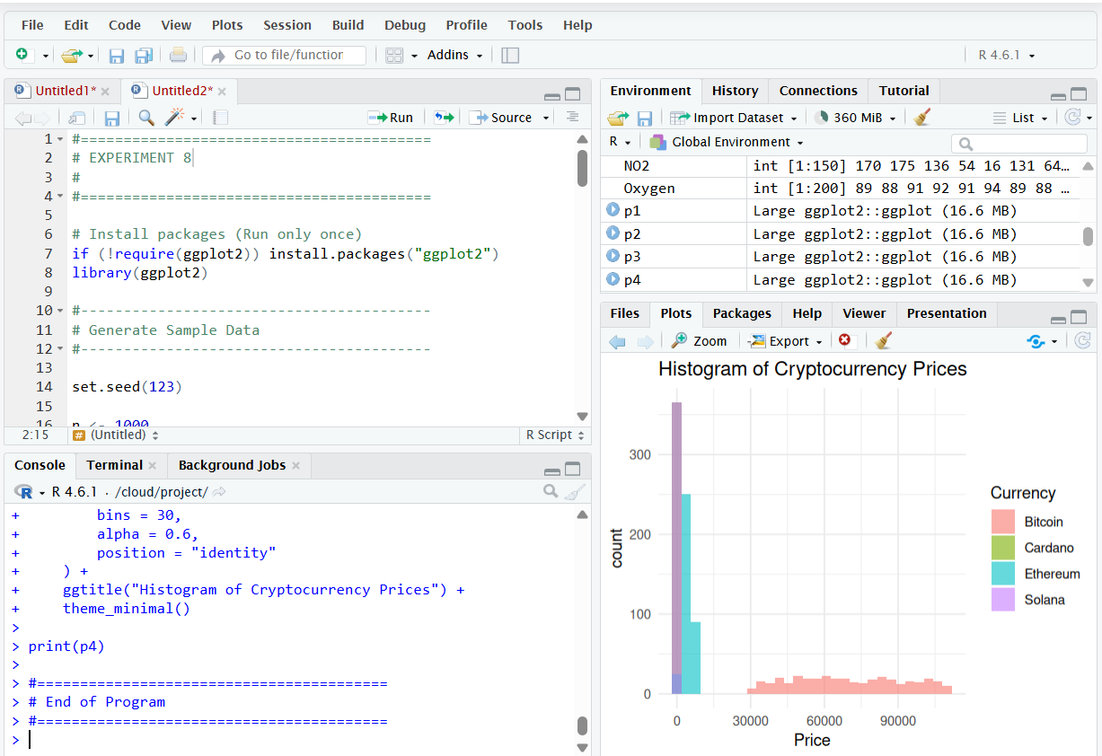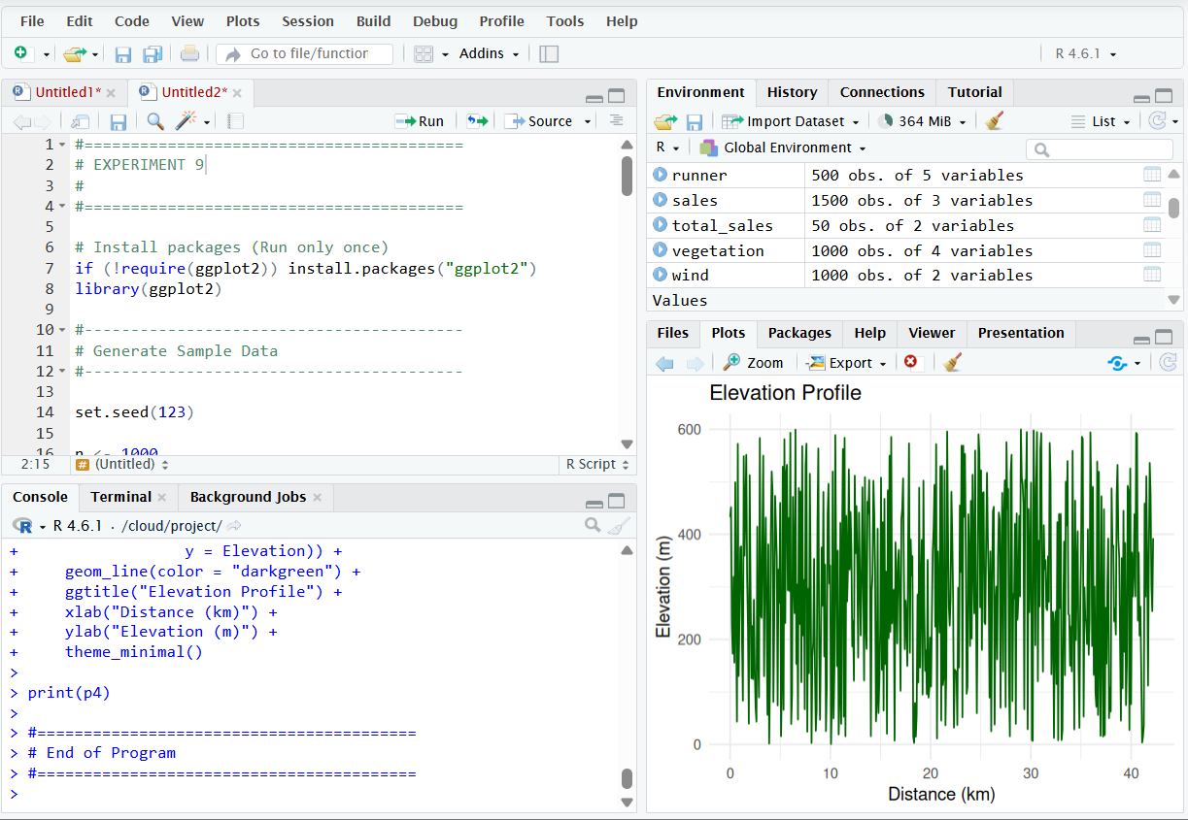

9)
#=========================================
# EXPERIMENT 9
# Marathon Runner Performance Analysis
#=========================================

# Install package (Run only once)
if (!require(ggplot2)) install.packages("ggplot2")
library(ggplot2)

#-----------------------------------------
# Generate Sample Data
#-----------------------------------------

set.seed(123)

n <- 500

Distance <- seq(0, 42.2, length.out = n)
Speed <- round(runif(n, 6, 18), 2)
HeartRate <- sample(90:190, n, replace = TRUE)
Elevation <- round(runif(n, 0, 600), 2)
Direction <- runif(n, 0, 360)

runner <- data.frame(
Distance,
Speed,
HeartRate,
Elevation,
Direction
)

head(runner)

#=========================================
# 1. Cartesian Plot
#=========================================

p1 <- ggplot(runner,
aes(x = Distance,
y = Speed,
color = Speed)) +
geom_line(size = 1) +
scale_color_gradient(
low = "blue",
high = "red"
) +
ggtitle("Runner Speed vs Distance") +
xlab("Distance (km)") +
ylab("Speed (km/h)") +
theme_minimal()

print(p1)

#=========================================
# 2. Polar Coordinate Plot
#=========================================

p2 <- ggplot(runner,
aes(x = factor(round(Direction/30)*30),
fill = Speed)) +
geom_bar() +
coord_polar() +
ggtitle("Running Direction (Polar Plot)") +
theme_minimal()

print(p2)

#=========================================
# 3. Heart Rate Plot
#=========================================

p3 <- ggplot(runner,
aes(x = Distance,
y = HeartRate,
color = HeartRate)) +
geom_line(size = 1) +
scale_color_gradient(
low = "green",
high = "red"
) +
ggtitle("Heart Rate During Marathon") +
theme_minimal()

print(p3)

#=========================================
# 4. Elevation Plot
#=========================================

p4 <- ggplot(runner,
aes(x = Distance,
y = Elevation)) +
geom_line(color = "darkgreen") +
ggtitle("Elevation Profile") +
xlab("Distance (km)") +
ylab("Elevation (m)") +
theme_minimal()

print(p4)

#=========================================
# End of Program
#=========================================
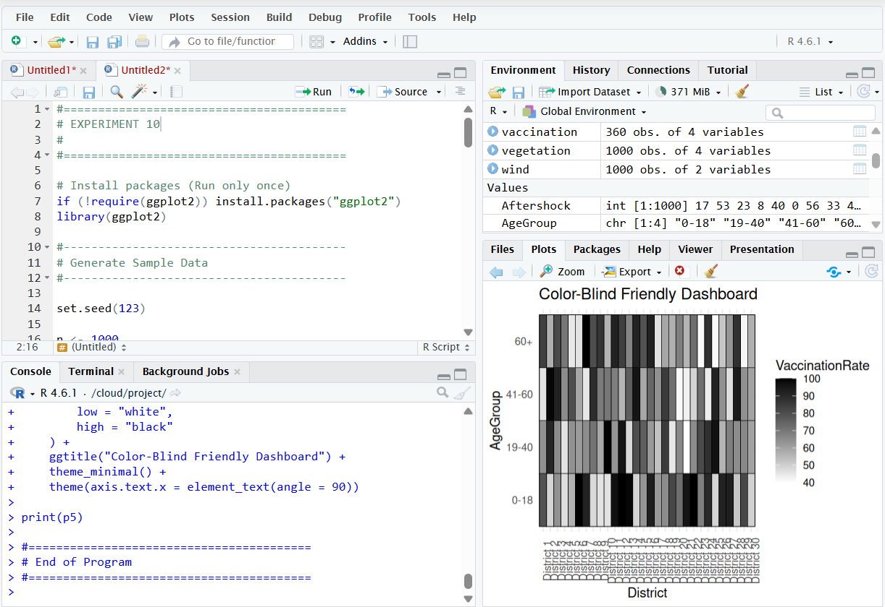

10)
#=========================================
# EXPERIMENT 10
# COVID-19 Vaccination Campaign Dashboard
#=========================================

# Install packages (Run only once)
if (!require(ggplot2)) install.packages("ggplot2")
library(ggplot2)

#-----------------------------------------
# Generate Sample Data
#-----------------------------------------

set.seed(123)

District <- paste("District", 1:30)
AgeGroup <- c("0-18", "19-40", "41-60", "60+")
Vaccine <- c("Covishield", "Covaxin", "Sputnik")

vaccination <- expand.grid(
District = District,
AgeGroup = AgeGroup,
Vaccine = Vaccine
)

vaccination$VaccinationRate <- sample(40:100,
nrow(vaccination),
replace = TRUE)

head(vaccination)

#=========================================
# 1. Heatmap for Policymakers
#=========================================

p1 <- ggplot(vaccination,
aes(x = District,
y = AgeGroup,
fill = VaccinationRate)) +
geom_tile() +
scale_fill_gradient(
low = "yellow",
high = "darkgreen"
) +
ggtitle("COVID-19 Vaccination Rates (Policy Dashboard)") +
xlab("District") +
ylab("Age Group") +
theme_minimal() +
theme(axis.text.x = element_text(angle = 90))

print(p1)

#=========================================
# 2. Public Dashboard - Bar Chart
#=========================================

district_total <- aggregate(
VaccinationRate ~ District,
vaccination,
mean
)

p2 <- ggplot(district_total,
aes(x = reorder(District, VaccinationRate),
y = VaccinationRate,
fill = VaccinationRate)) +
geom_col() +
coord_flip() +
scale_fill_gradient(
low = "lightblue",
high = "blue"
) +
ggtitle("Average Vaccination Rate by District") +
xlab("District") +
ylab("Average Vaccination Rate (%)") +
theme_minimal()

print(p2)

#=========================================
# 3. Vaccine-wise Box Plot
#=========================================

p3 <- ggplot(vaccination,
aes(x = Vaccine,
y = VaccinationRate,
fill = Vaccine)) +
geom_boxplot() +
ggtitle("Vaccination Rate by Vaccine Type") +
theme_minimal()

print(p3)

#=========================================
# 4. Age Group Comparison
#=========================================

age_total <- aggregate(
VaccinationRate ~ AgeGroup,
vaccination,
mean
)

p4 <- ggplot(age_total,
aes(x = AgeGroup,
y = VaccinationRate,
fill = AgeGroup)) +
geom_bar(stat = "identity") +
ggtitle("Average Vaccination Rate by Age Group") +
xlab("Age Group") +
ylab("Average Vaccination Rate (%)") +
theme_minimal()

print(p4)

#=========================================
# 5. Accessibility Version
#=========================================

p5 <- ggplot(vaccination,
aes(x = District,
y = AgeGroup,
fill = VaccinationRate)) +
geom_tile(color = "black") +
scale_fill_gradient(
low = "white",
high = "black"
) +
ggtitle("Color-Blind Friendly Dashboard") +
theme_minimal() +
theme(axis.text.x = element_text(angle = 90))

print(p5)

#=========================================
# End of Program
#=========================================
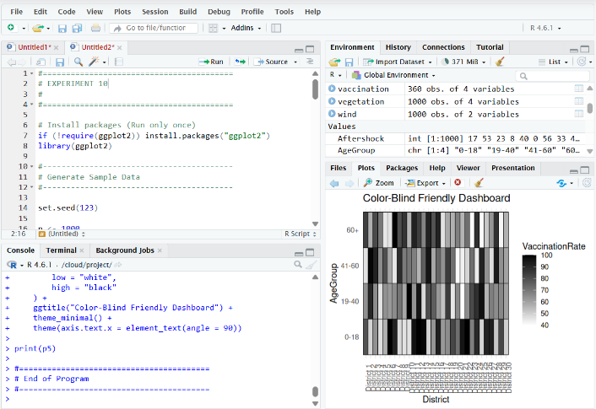
Python codes
- Smart City Air Quality Monitoring
import matplotlib.pyplot as plt

# Sample data
location = [1, 2, 3, 4, 5]
pm25 = [30, 60, 90, 50, 80]
level = ["Low", "Moderate", "High", "Moderate", "High"]

# 1. Sequential Palette
plt.scatter(location, pm25, c=pm25, cmap="Blues", s=100) plt.title("Sequential Palette")
plt.xlabel("Location") plt.ylabel("PM2.5") plt.colorbar(label="PM2.5") plt.show()

# 2. Diverging Palette
plt.scatter(location, pm25, c=pm25, cmap="coolwarm", s=100) plt.title("Diverging Palette")
plt.xlabel("Location") plt.ylabel("PM2.5") plt.colorbar(label="PM2.5") plt.show()

# 3. Qualitative Palette
colors = ["green", "orange", "red", "orange", "red"] plt.scatter(location, pm25, c=colors, s=100) plt.title("Qualitative Palette")

plt.xlabel("Location") plt.ylabel("PM2.5") plt.show()

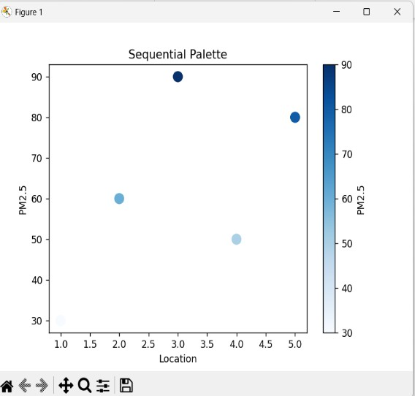
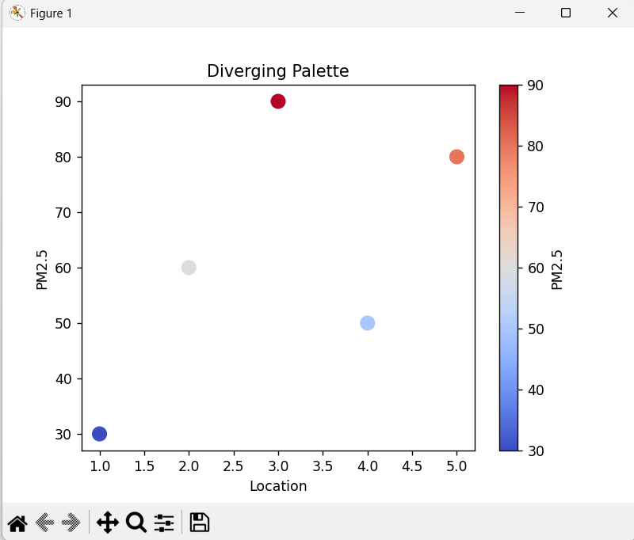
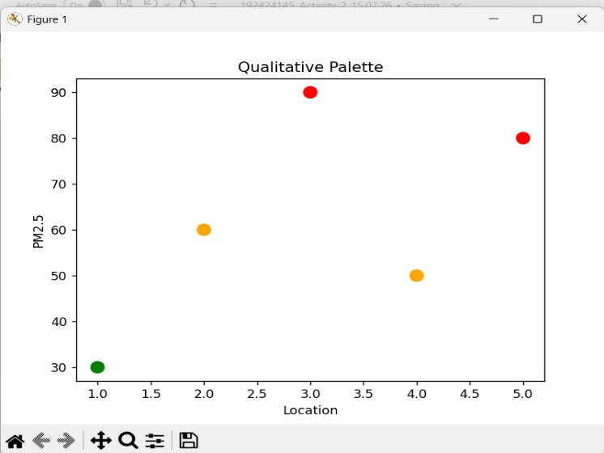

- Earthquake Risk Analysis
import matplotlib.pyplot as plt

# Sample data
magnitude = [0.5, 1, 2, 3, 5, 7, 9]
depth = [20, 40, 80, 150, 250, 500, 700]

# Linear Scale
plt.scatter(magnitude, depth, color="blue") plt.title("Earthquake Risk Analysis (Linear Scale)") plt.xlabel("Magnitude")
plt.ylabel("Depth (km)") plt.show()

# Logarithmic Scale plt.scatter(magnitude, depth, color="red") plt.yscale("log")
plt.title("Earthquake Risk Analysis (Log Scale)") plt.xlabel("Magnitude")
plt.ylabel("Depth (km)") plt.show()
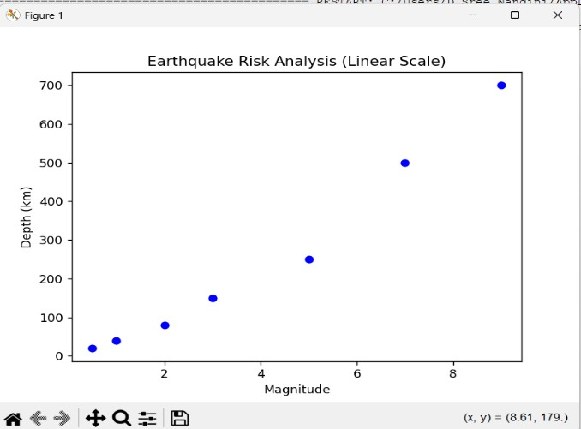
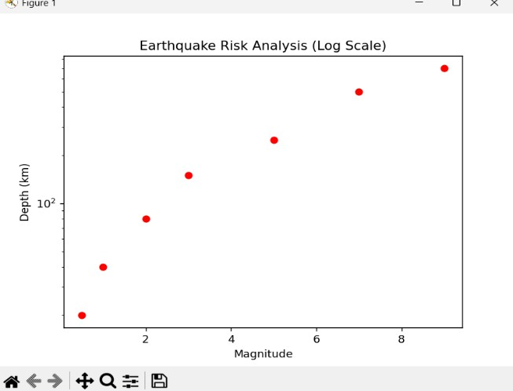

- Wind Direction Analysis for Airport Operations

Cartesian Plot
import matplotlib.pyplot as plt

direction = ["N", "NE", "E", "SE", "S", "SW", "W", "NW"] speed = [12, 18, 10, 8, 15, 20, 14, 11]

plt.bar(direction, speed)
plt.title("Wind Direction - Cartesian Plot") plt.xlabel("Direction")
plt.ylabel("Speed") plt.show()
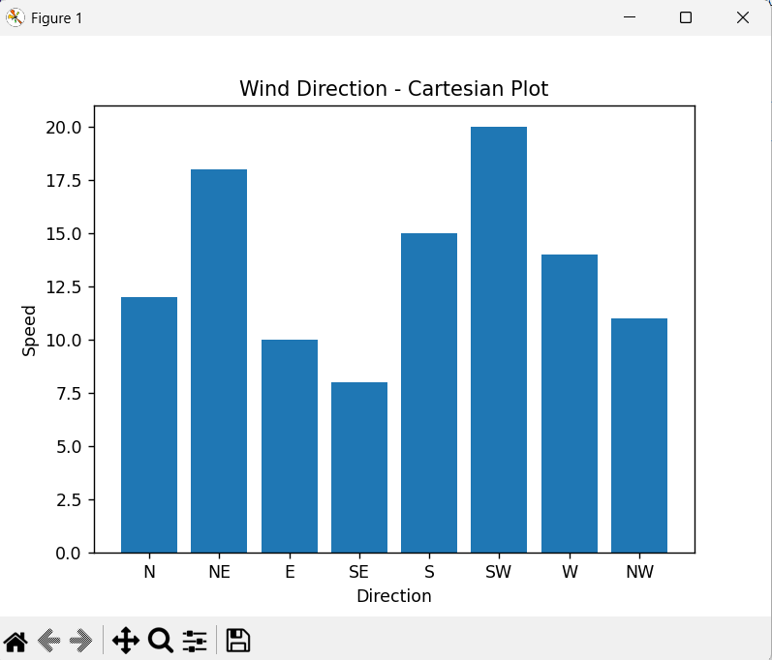

Polar Plot (Wind Rose) import matplotlib.pyplot as plt import numpy as np

speed = [12, 18, 10, 8, 15, 20, 14, 11]
theta = np.linspace(0, 2*np.pi, len(speed), endpoint=False)

ax = plt.subplot(111, polar=True) ax.bar(theta, speed, width=0.5)

plt.title("Wind Rose") plt.show()
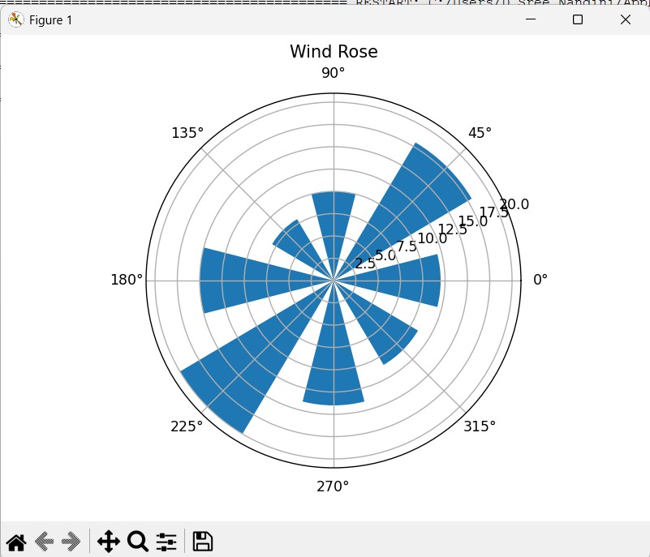

- Hospital Patient Monitoring Dashboard
import matplotlib.pyplot as plt

parameters = ["Heart Rate", "Oxygen", "BP", "Respiration", "Temperature"] values = [130, 88, 140, 28, 39]
colors = ["red", "green", "red", "orange", "red"]

plt.bar(parameters, values, color=colors)

plt.title("Hospital Patient Monitoring Dashboard") plt.xlabel("Parameters")
plt.ylabel("Values")

plt.show()

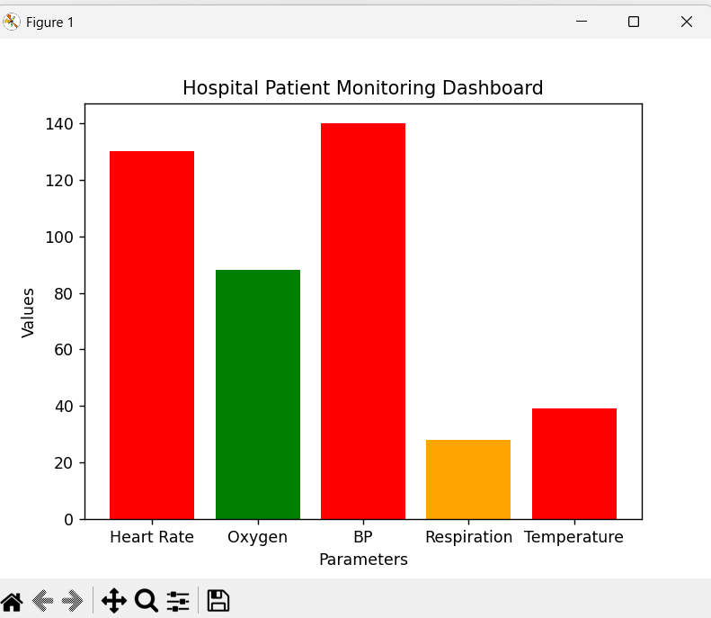

- Global Climate Change Study import matplotlib.pyplot as plt import numpy as np

data = np.array([
[-1.5, -0.5, 0.2],
[0.5, 1.0, 1.8],
[-0.8, 0.3, 2.0]
])

# Heatmap
plt.imshow(data, cmap="coolwarm") plt.colorbar(label="Temperature Anomaly") plt.title("Global Climate Change Heatmap") plt.show()
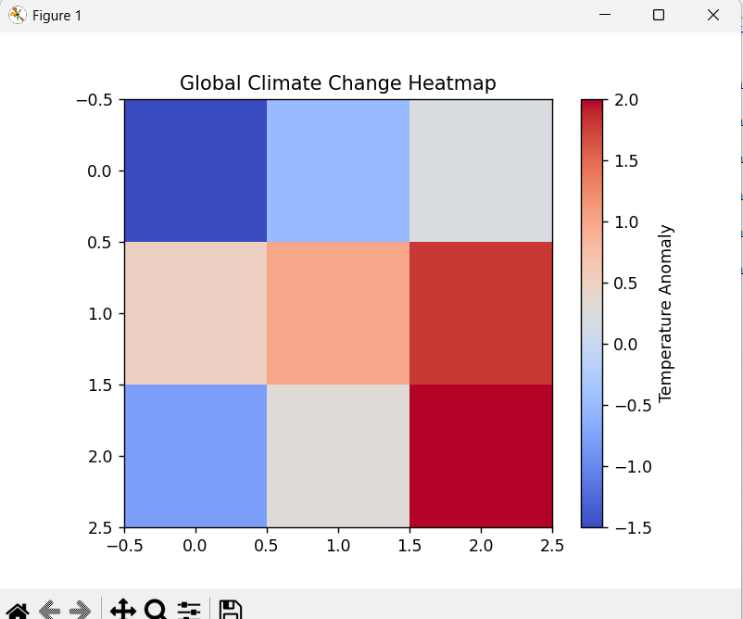

- E-Commerce Sales Analytics
import matplotlib.pyplot as plt

category = ["Electronics", "Clothing", "Furniture", "Toys"] sales = [500, 300, 400, 600]

plt.bar(category, sales, color=["red", "blue", "green", "orange"])

plt.title("E-Commerce Sales Analytics") plt.xlabel("Product Category") plt.ylabel("Sales Volume")

plt.show()

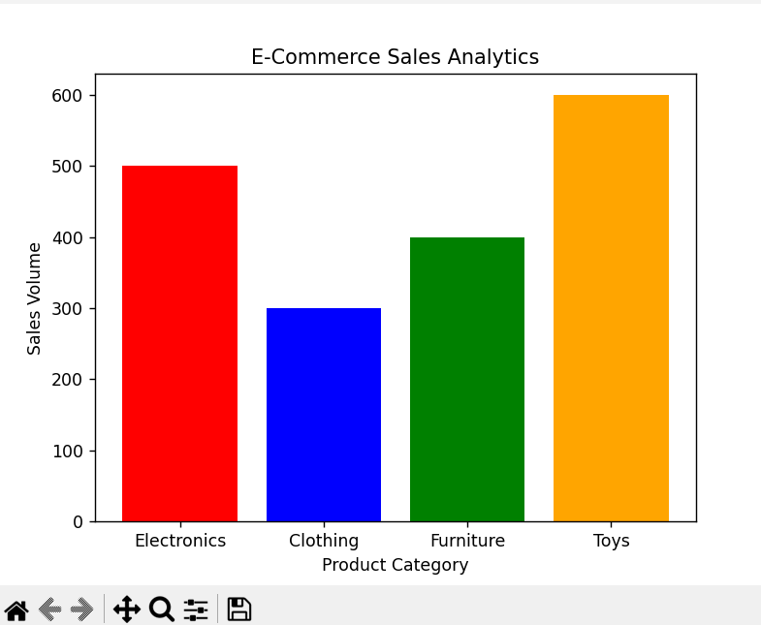

- Satellite Image Vegetation Analysis
import matplotlib.pyplot as plt

area = ["A", "B", "C", "D", "E"] ndvi = [-1, -0.5, 0, 0.5, 1]

plt.bar(area, ndvi, color=["blue", "cyan", "yellow", "lightgreen", "green"])

plt.title("Satellite Image Vegetation Analysis") plt.xlabel("Area")
plt.ylabel("NDVI")

plt.show()

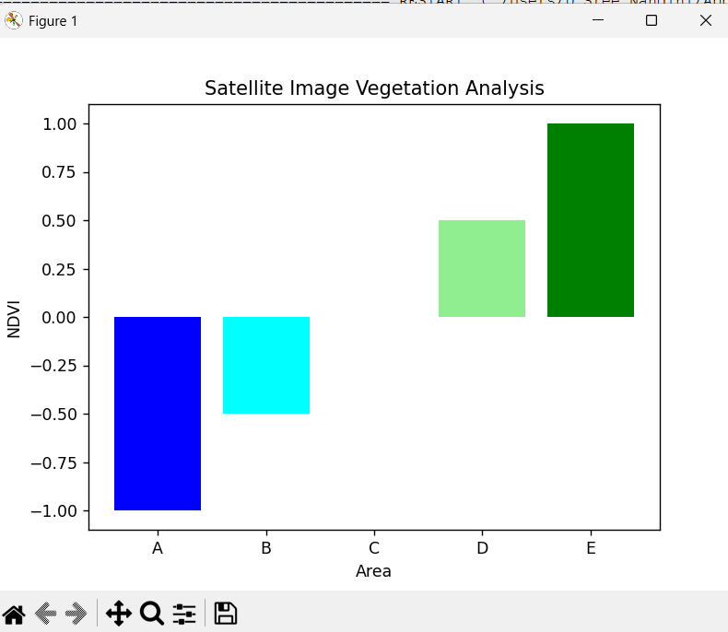

- Cryptocurrency Market Volatility
import matplotlib.pyplot as plt

day = [1, 2, 3, 4, 5]
bitcoin = [30000, 35000, 40000, 45000, 50000]

plt.plot(day, bitcoin, color="blue") plt.yscale("log")

plt.title("Cryptocurrency Market Volatility") plt.xlabel("Day")
plt.ylabel("Price (Log Scale)")

plt.show()

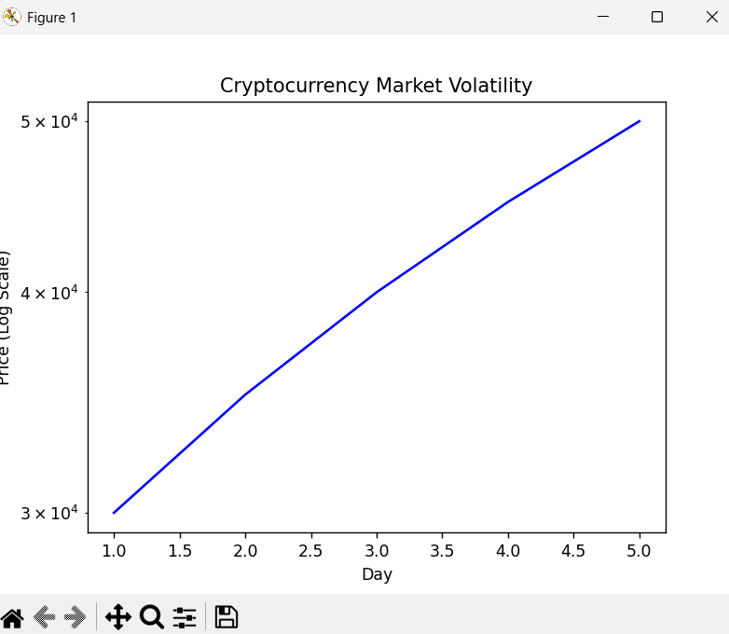

- Marathon Runner Performance Analysis

Cartesian Plot
import matplotlib.pyplot as plt

distance = [5, 10, 15, 20, 25]
speed = [10, 12, 11, 13, 12]

plt.scatter(distance, speed, c=speed, cmap="viridis") plt.colorbar(label="Speed")
plt.title("Marathon Runner Performance") plt.xlabel("Distance")
plt.ylabel("Speed") plt.show()
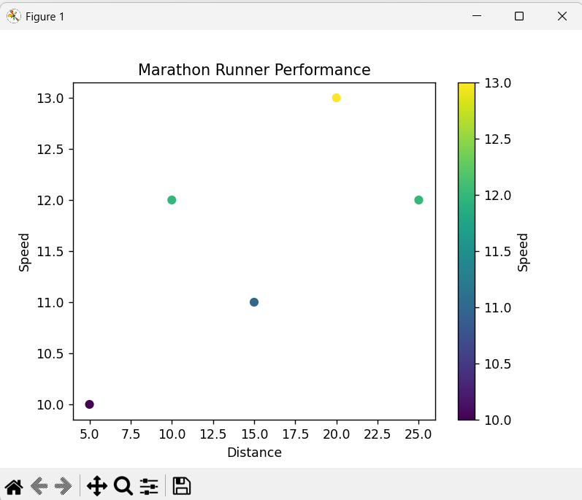

Polar Plot
import matplotlib.pyplot as plt import numpy as np

speed = [10, 12, 11, 13, 12]
angle = np.linspace(0, 2*np.pi, len(speed), endpoint=False)

plt.polar(angle, speed, 'o-') plt.title("Runner Direction (Polar Plot)") plt.show()
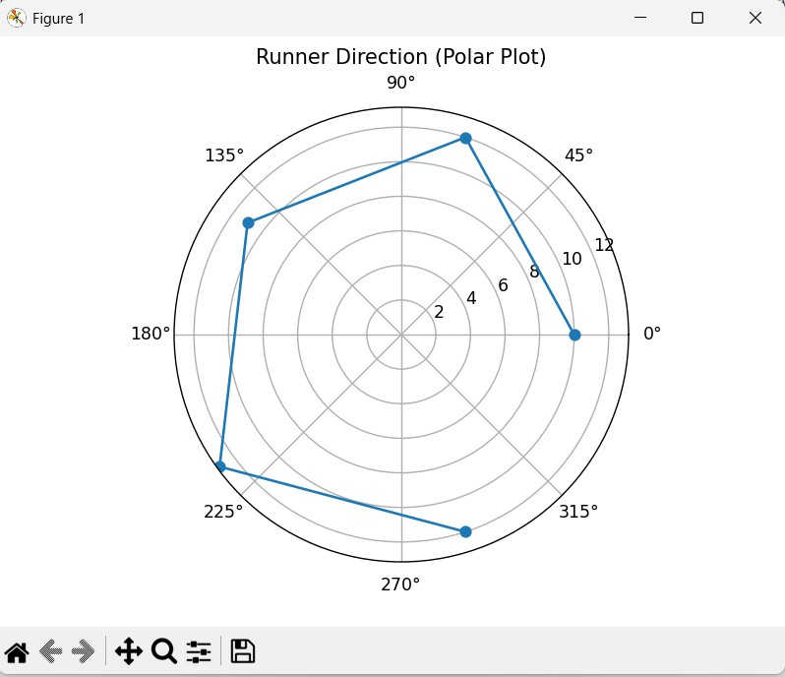

- COVID-19 Vaccination Campaign Dashboard

Version 1 – Blue Color Palette (For Policymakers)
import matplotlib.pyplot as plt

district = ["A", "B", "C", "D", "E"] rate = [60, 75, 90, 80, 65]

plt.bar(district, rate, color="blue") plt.title("COVID-19 Vaccination Rates") plt.xlabel("District") plt.ylabel("Vaccination Rate (%)") plt.show()
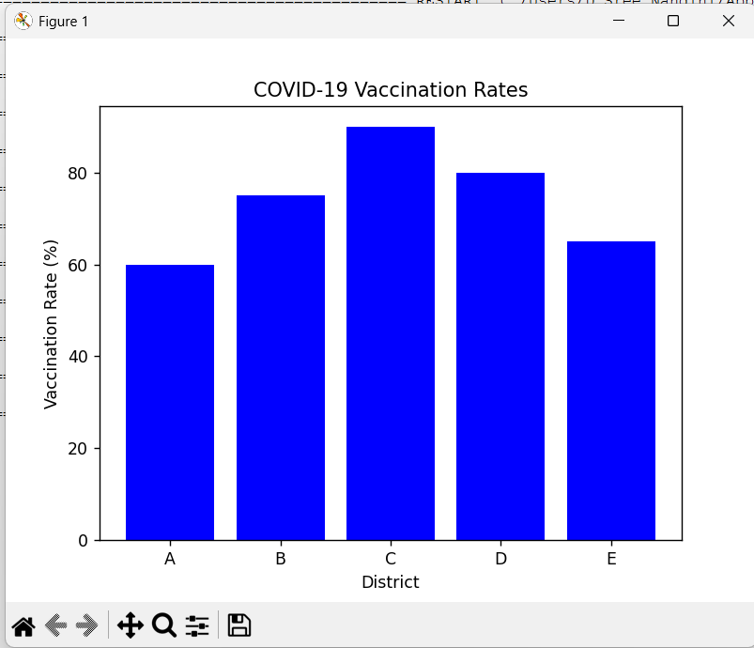

Version 2 – Green Color Palette (For General Public)
import matplotlib.pyplot as plt

district = ["A", "B", "C", "D", "E"] rate = [60, 75, 90, 80, 65]

plt.bar(district, rate, color="green") plt.title("COVID-19 Vaccination Rates") plt.xlabel("District") plt.ylabel("Vaccination Rate (%)") plt.show()
